DEPAUL ESC HOST PROJECT INFORMATION

DEPAUL is a charity that supports vulnerable people who are homeless or at risk of homelessness. We provide accommodation and key services, aimed at giving our service users an opportunity to fulfil their potential and move towards an independent and positive future. We believe that homelessness has no place in our society. Depaul is part of the wider Depaul International group structure, with other subsidiaries in the UK, Ukraine, Croatia, Slovakia, USA and France. We are part of the Vincentian family of organisations, inspired by the life and teachings of St. Vincent de Paul. Our staff and service users are drawn from all walks of life, of many faiths or no faith at all. We are non-judgmental in the same way that St. Vincent was and focus on innovation and action.
Our organisation is driven by a very strong vision, mission and set of values:

DEPAUL’S VISION is of a society in which everyone has a place to call home and a stake in their community.
DEPAUL’S MISSION is to end homelessness and change the lives of those affected by it.
We believe that we cannot achieve our vision & mission without the active involvement of volunteers in our work. By participating with Depaul, you will be given the opportunity to work with a values-led organisation that focuses on the following in all areas of work:
DEPAUL’S VALUES
- We celebrate the potential in people
- We put our words into action
- We aim to take a wider role in civil society
- We believe in rights and responsibilities

Depaul’s Volunteer Department is dedicated to maintaining a quality European Solidarity Corps programme in which participants and service users alike can unlock their potential and learn from each other in a supportive environment. Participants are involved to help us provide a range of beneficial opportunities for our service users through a variety of roles. Additionally, as a participant you will experience first-hand our approach to the issue of homelessness and how we work with and value those affected by it. Our focus is on innovation and action.
Our service users come from all backgrounds and may have a range of complex issues that have led them to become homeless or at risk of homelessness. This may include mental health problems, domestic violence, bereavement, unemployment, alcohol, addictions issues, etc.

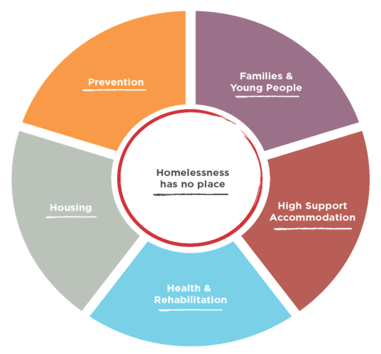
We give support in 5 main service areas:

- Prevention
- Families & Young People
- High Support Accommodation
- Health & Rehabilitation
- Housing
WHERE ARE WE?
In Ireland, Depaul services are located in both the Republic of Ireland and Northern Ireland. Our host projects for our ESC programmes are situated in Dublin. Dublin is the capital of the Republic of Ireland and is a social and cultural hub teeming with local Dubliners alongside people from all over the world. Dublin offers something for everyone, boasting a diverse and multicultural population and a multitude of cuisines, museums, art galleries, theatres, cinemas and sporting activities. The city centre has seen much modernisation, while retaining its beautiful Georgian architecture, along with its medieval core. Dublin combines the lively tourist presence and bustling nightlife of a major European capital city with the warm and friendly feeling of a small town; Covid-induced lockdown and restrictions notwithstanding!
Dublin has its own international airport, with flights connecting it to the UK, the rest Europe and the USA, many of which are provided by Aer Lingus and Ryanair, amongst others. For local and domestic transport, Dublin provides access to buses and trains that can connect you with almost anywhere on the island of Ireland.
The majority of Depaul’s Dublin projects are located in or around the city centre, and are accessible on foot or by bus from our volunteer accommodation. The cost of living can be quite high in Dublin, but since your accommodation and some basic foods are provided by Depaul, if you are careful with your money, you should find it manageable.

WHY DO WE NEED PARTICIPANTS?
At Depaul, we see volunteers as an important aspect of achieving our mission. This includes part-time volunteers, student placements, full-time volunteers from Ireland and our ESC participants. Having ESC volunteers participate at our host projects is at the heart of the Vincentian ethos that drives all of our services. ESC participants are an essential part of our work, and our projects would not be the same without them. Our host projects are managed by full-time qualified, paid staff for basic functions and support, and we rely on volunteers to use their time and energy to provide a great variety of fun and engaging activities that otherwise wouldn’t be possible. They bring something unique to the organisation.

HOW DO PARTICIPANTS HELP?
- By enhancing the range of services that we can provide for our service users
- By bringing a big intercultural dimension to the lives of our service users
- By offering activities that promote positive life skills and independence
- By encouraging the service users to participate in varied activities
- By providing social interaction for which paid staff do not have the availability or time
- By supporting a holistic approach in service delivery plans
- By making life in our projects fun for our service users, staff and other volunteers

WHAT DO PARTICIPANTS DO?
The most important thing our volunteers can do is to bring social interaction into our host projects. ESC participants bring a wealth of energy, enthusiasm, culture, experience and knowledge that enhances the service we can provide. They can do this by building valuable, supportive relationships with our service users. As an ESC participant, you might find yourself organising or getting involved in a variety of different activities aimed at boosting the skills and self-esteem of our service users, while developing your own skills and gaining new experiences. For example, you might organise:

- Art, crafts or music workshops
- Life skills classes, such as basic literacy & numeracy, computers, cooking, job skills
- Games and quizzes
- Movie nights, exercise or mindfulness classes, developing cultural awareness
- Seasonal parties or holiday celebrations (St. Patrick’s Day, Halloween, Christmas, etc.)
- Organisational events, fundraising activities, workshops, conferences etc.
- Befriending activities

The project staff will encourage you to take initiative in arranging such activities as soon as you feel comfortable doing so. You will be encouraged to consult with the staff and service users to identify, plan and budget for activities that are suitable for your specific project, the service user group and your own interests and abilities. Staff can support this work and conduct risk assessments for new activities if necessary. Part-time volunteers and student placements are also part of the project, and it is likely that you will work closely with them to form collaborative activities and support each other.

A volunteer role does NOT include:

- Covering or substituting a paid staff role
- Over night shifts
- Key-working (personal support)
- Counselling / therapy roles

WHAT ARE THE BENEFITS?
Depaul considers volunteering to be a two-way, mutually beneficial arrangement, and your ESC placement can be a very enriching time for you as well as for our service users. You will come into contact with groups of people who suffer from issues and problems that you may not have encountered before. This can be challenging, but you will be given plenty of support, and ultimately benefit from a unique experience.
We look for candidates who can envision how their hobbies and interests will generate ideas and form meaningful activities for the engagement of the service users. We will discuss your hopes for your ESC placement and beyond; the development you hope to gain and how this will benefit you in the future.
We foresee improved self-confidence for you and our service users, development and use of new skills, knowledge and behaviour, and active cooperation with our local communities and beyond. We want you to have a quality volunteering experience, developing skills such as independent living and proficiency in English. This experience will also allow you to gain experience in the social care sector and explore new career possibilities in a supportive environment. You will gain new perspectives into homelessness and social exclusion and will experience different approaches to dealing with these issues, and will be able to bring the awareness and skills you have gained back to your families, peers and communities at home. Meanwhile, our service users will have increased opportunities for social interaction and harm reduction through the activities, outings and interactions that you organise. They can discover new interests, hobbies and talents. In turn, we at Depaul will learn from your culture, interests, energy and expertise, and share this learning across the organisation to make the services we provide even better.
You will gain experience in a broad range of areas that can be extremely beneficial to your future and personal development. These include:

- Good communication skills
- An ability to respond appropriately to challenging situations
- An understanding of providing professional support for vulnerable people
- An understanding of issues surrounding homelessness
- An understanding of harm reduction and low threshold working practices
- Experience of a holistic style of working

Furthermore, you will meet a wide range of people from Ireland and all over the world. You will interact with other ESC participants engaged in homeless services and many other projects. You will work closely with qualified, professional staff who might be able to guide you in your future career, and the Volunteer Department will remain in contact after you return home. After one year, you will have developed new networks, and hopefully some lifelong friends.

WHAT ARE THE CHALLENGES?
While the Volunteer Coordinators will work closely with your Supporting Organisation to prepare for your arrival and try to make your transition into your project run as smoothly as possible, we are aware that engaging in a year-long ESC project is a big undertaking. We have been managing projects and volunteers for several years, and are aware of some of the challenges you might face. Prior to your departure for Dublin and throughout your induction, we focus on identifying and overcoming these challenges. These might include:
- Settling into a new city and environment
- Learning to live with your housemates
- Getting used to communicating in English
- Managing homesickness
- Understanding the Irish accent, local sayings and slang terms
- Service users’ apathy
- Service users’ physical and/or mental health issues
- Service users’ chaotic lifestyles, and the impact these can have on the project
- Our service users can be difficult to engage:
- They might be alcohol and/or drug dependent and can be under the influence
- They might have varying mental health issues
- They might function independently without an interest in engaging with volunteers

PRACTICAL INFORMATION

Essential Skills for ESC Participants

- Being patient, while attempting to inspire and motivate a challenging group of service users
- Staying empathic and non-judgmental, while working with people facing complex issues
- Using initiative and staying flexible and open to new situations
- Having a basic understanding of the issues surrounding homelessness
- Being able and willing to work with people who are on the margins of society
- Having a good level of written and spoken English – enough to have a good conversation with the service users

In Ireland
You will have a single room in our volunteer house. The house is located close to the host projects, near the city centre. The house will be shared with other ESC participants from all over Europe, and we imagine that you will form a close-knit group with your housemates, and come to rely on each other for fun and support.

You will be provided with a pocket money allowance of €100, paid weekly. Depaul will provide this via bank transfer into internet-based bank accounts, such as Revolut, unless circumstances prevent this. These bank accounts are best established prior to your arrival in Ireland. While meals are not provided, some basics, such as tea, coffee and dried goods are provided to help with food and other basic needs. The kitchen, living room and bathrooms are available for use by everyone residing in the house, and are fully furnished and equipped with bedding, pots and pans, sheets, etc. In the spirit of solidarity and cooperation, we encourage you all to cook, eat and socialise together regularly. If your host project has catering facilities, you may have meals there, otherwise you will be responsible for your own meals while on site.
You will have annual leave/time-off that you can use as you please, although we encourage you to take regular breaks throughout your placement. Many participants utilise this time to explore other areas in Ireland, or occasionally to visit home. Participants are entitled to 25 days of annual leave throughout their 12-month placement, along with Irish Bank Holidays.
Furthermore, every ESC participant receives on-arrival training and mid-way training facilitated by the National Agency. This aims to prepare you for your placement and your stay in Dublin, and contains a strong cultural element in order to provide you and your fellow participants with some background of cultural similarities and differences between Ireland and your home countries.

Support & Development
You will have a placement Supervisor and Mentor, and meet with them regularly throughout your project. They will introduce you to the organisation, provide support and ensure that you are getting a good balance between intercultural learning opportunities and voluntary work.

Arrival
A variety of cultural experiences and interactions are important in an ESC placement. Depaul’s Volunteer Department provides a comprehensive induction, initially for the first two weeks after your arrival in Ireland. During this time, we will tell you all about the organisation, and take you and your fellow participants on a tour of the host projects, and help you to become familiar with the city. You will have many opportunities to visit sites of historical and cultural significance with the Volunteer Coordinators, fellow volunteers and the service users from your project throughout your placement (Covid allowing!) During your time with us, you will learn a lot about Ireland and different aspects of our history and traditions. We promote the celebration of Irish festivals among our participants, and will encourage you to try local specialties and activities.

Health and Safety
Depaul takes the Health and Safety of every volunteer very seriously. The host projects have been specifically designed with the health and safety of staff, volunteers and service users in mind. Depaul will follow international guidelines and best practice, along with our own stringent protocols around the ongoing Covid-19 pandemic, to ensure that all staff, volunteers and service users are kept safe. These measures might include the requirement to self-quarantine upon arrival, and ongoing social distancing, mask use and other hygiene procedures.

You will receive a local induction at your specific host project, helping you to familiarise yourself with the premises and get to know the staff, service users and other volunteers. The management and staff of the project will always be on hand, in case you ever need support from them. For your first few weeks on-site, you will spend a lot of time ‘shadowing’ the project workers – spending time with them, observing their activities and interactions, getting to know the project and maybe forming some ideas of your own. You will receive lots of support at this stage, to help you become familiar with the building, its policies and procedures and the service users, while ensuring that you are comfortable, safe and happy during this early induction phase.

Language Support
Depaul will follow ESC guidelines for specific language support. Participants are expected to complete the Online Language Support (OLS) assessment through the ESC program prior to arrival. If you would like to complete the entire OLS course, your host project will provide you with the time and availability to do so. Aside from this, Depaul can help to locate free language resources for you if you would like to avail of them. We will review this as further information is available.

Project Activities

A typical week for you might look something like this:

 | Morning | Afternoon | Evening
Monday | Socialising with the service users in the host project. Playing pool or chatting. | Preparation of the art and crafts materials followed by workshop  (7 hour day) | Free
Tuesday | Accompanying a service user to the local shops. | Attendance at Team meeting & working with service users on health promotion project.  (7 hour day) | Free
Wednesday | Working at another Depaul project with another ESC volunteer on a cultural activity. | Free | Quiz Night  (6 hour day)
Thursday | Free | Meeting with staff & volunteers to prepare for a trip to a local park with service users. | Music Night  (6 hour day)
Friday | Morning Breakfast Club | Cooking Session – life skills support for adults (7 hour day)
Saturday | Day Off | Free
Sunday | Day Off | Free

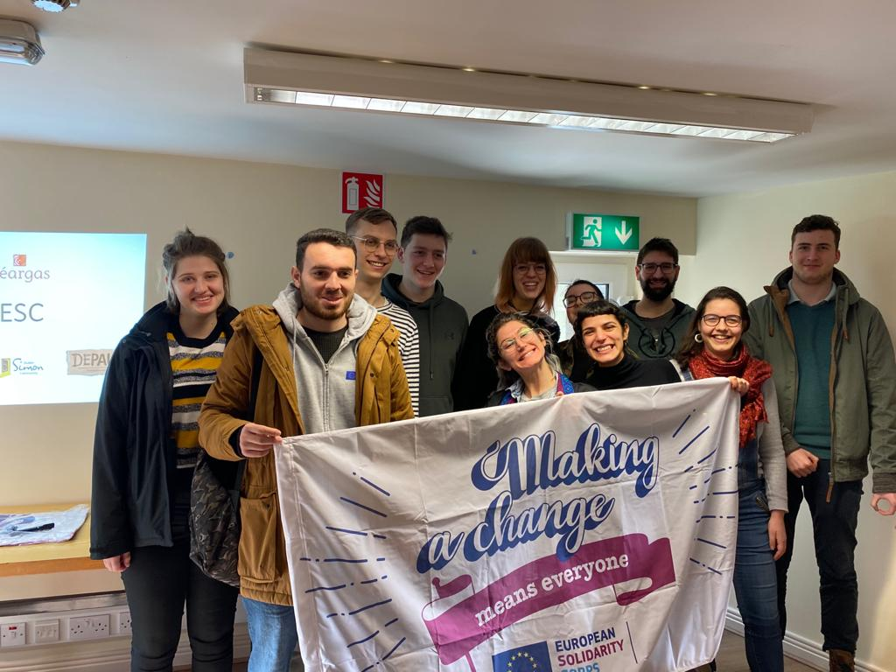
REPUBLIC OF IRELAND HOST PROJECTS:

SUNDIAL HOUSE
Sundial House is a specialised long-term accommodation service that houses 30 vulnerable men, women and couples who have entrenched alcohol use issues, and a history of extended periods of rough sleeping. Purpose built in 2008 as a high quality, high support accommodation, many of the individuals living here have complex support needs. A key low-threshold and harm-reduction support accommodation in Dublin, Sundial House offers a variety of hands-on services to help service users reach achievable goals and address any health-related issues. Sundial House provides a warm, homely, secure environment offering onsite supports for people with complex support needs with an aim to provide all residents with the help they need to live healthy and positive lives.

Services offered:
- Private quality accommodation (single and double bedrooms with en-suite bathrooms)
- One-to-one professional support through key-working sessions
- Practical and holistic assistance
- Harm reduction addiction support
- 3 rooms for those with enhanced care needs
- Weekly GP service
- Health care assistant and nursing support onsite
- Referral, advocacy and case management
- On-site alcohol management programme
- Volunteer-led activities
- Life skills development programme

Sundial House is a unique project as it is intended to provide long-term accommodations for its service users, which sometimes means housing for life. This makes the role of an ESC volunteer at Sundial especially rewarding because they are given the opportunity to really get to know and work with the service users at this project. For this reason, and many others, it is especially important that volunteers here are dedicated to their participation and committed to getting the service users excited and involved.

Sundial House Tasks
Spending time to talk and get to know the service users and to prepare activities with service users such as:
- Life skills: Literacy, health awareness, hygiene, meditation, yoga
- Arts & Crafts: Painting, mosaics, crafts
- Cookery: Breakfast clubs/baking classes
- Photography, creative projects
- Gardening
- Accompany service users on trips outside the project/Befriending
- Social activities – Films, games, quizzes, pool, bingo
- Volunteer’s Personal Project – build on your own personal skills & interests

Sundial House has a variety of large spaces for volunteer activities. The ground floor has a communal eating space for meal-times as well as breakfast clubs, there is a large garden accessible from the top floor, and each floor at this project has a large recreation room with TVs and additional space for activities.

ORCHID HOUSE
Orchid House provides supported temporary accommodation for up to 23 men, women and couples with a history of extended periods of homelessness, entrenched alcohol issues and complex needs such as mental health issues. As temporary accommodation, residencies at Orchid House are intended for periods of up to six months, but with the increasingly challenging housing situation in the Dublin area, some residents have been with us for longer periods.

Services offered:
- Private accommodation (bedrooms for individuals and couples)
- One-to-one professional support through key-working sessions
- Practical and holistic assistance
- Harm reduction addiction support; including an alcohol management programme
- Referrals, advocacy and case management
- Independent living skills development
- Volunteer-led activities
- Resettlement support

Working within the principles of harm reduction, Orchid House works with service users by meeting them where they’re at to provide the best possible services for them. The project is a ‘wet hostel’, one at which service users can consume their own alcohol on site under a structured alcohol management programme. People with a long history of alcohol misuse can often be discriminated against in seeking social assistance; therefore, the support Depaul provides allows us to support those who need it most.

Orchid House Tasks
Taking the time to talk to and get to know the service users and to prepare activities such as:
- Life skills: literacy, health awareness, hygiene, relaxation
- Arts & crafts: painting, mosaics, clay modelling
- Cookery: breakfast clubs, baking
- Photography, creative projects
- Gardening
- Accompanying service users on trips outside the project; engaging in community projects and clubs
- Social activities: film, games, quizzes
- Your personal project: build on your own personal skills & interests
- Collaboration with Sundial House ESC participant (next door!) to create joint activities e.g. trips, game tournaments, etc.

Orchid House has access to communal spaces such as tv and games rooms, computer access for learning and other practical activities, a kitchen and a small garden that can be utilised for these and other activities.

BACK LANE
Back Lane is a 60-bed all-male hostel that provides both supported temporary and long-term accommodation for individuals of various ages who are experiencing homelessness. The residents at this service have complex support needs ranging from mental health issues to substance/alcohol abuse. This hostel has been in operation since 1915 and provides a very homely experience for all who enter its doors. Offering various supports to suit its wide range of service users, support at Back Lane can come in various forms, ranging from life skills development to hands on health support that is provided with the assistance of Depaul’s onsite nurse manager.

Services offered:
- Private accommodation (single and double bedrooms with en-suite bathrooms)
- One-to-one professional support through key working sessions and access to additional resources
- Practical and holistic assistance
- Harm reduction addiction support
- Referral, advocacy and case management
- Independent living skills development
- Volunteer-led activities
- Resettlement support; includes initial assistance acquiring basic supplies for new homes when they are able to move on

The ESC volunteer at Back Lane will work alongside, and be part of, a large team of full-time staff and numerous part-time volunteers and student placements. This will add to the basic services the staff can provide for service users.

One unique aspect of this service is that it has essentially two sides. Services users in the long-term accommodation section are generally older services users, many with health problems that limit mobility, while those in supported temporary accommodation are of a younger, more active age group. One of the tasks of the ESC volunteer here would be to engage this diverse group of service users individually or in small groups. This can include activities in the project itself or also away from the project, while utilising the unique location of Back Lane (city centre). In all such activities volunteers will be supervised either by their supervisor or by project staff.

Back Lane Tasks
The focus for an ESC volunteer at Back Lane will be spending time to talk to and get to know the service users. Additionally, the volunteer will prepare activities to participate in with service users such as:
- Life Skills: Literacy, health awareness, hygiene, relaxation
- Arts & Crafts: Painting, mosaics, crafts
- Photography, creative projects
- Gardening: There is access to a large garden and outdoor area in the backyard
- Accompany service users on trips outside the project; befriending
- Social Activities: Films, games, quizzes, pool, bingo
- Volunteer’s Personal Project – Build on your own personal skills & interests

Back Lane has a large communal area with tables and chairs that is typically used for meals but can also be repurposed for volunteer activities. There is also a large recreational area that has seating/couches and a pool table which is very popular among residents, as well as two other television rooms. The hostel also has a large backyard with a garden that is maintained by one of the service users. Not only does this project have space for a variety of activities, but it is also common that the service users here participate in various community/off-site activities as well.

Also, one aspect of this service that makes it unique is that the community befriending programme, which operates out of Back Lane hostel. This programme engages with service users that have moved on to their own homes and pairs them up with a volunteer who would then check in with them during regular chats and hangouts at coffee shops, etc. In addition to these chats, the individuals who participate in this programme are also invited to engage in group outings to various places and activities around Dublin. The programme also operates within the service itself, and these participants are also invited to engage in the group outings.

PETER’S PLACE
Peter’s Place is a welcoming full-time supported temporary accommodation service for up to 35 young men and women between the ages of 18 and 35 who are experiencing homelessness. Stays here are intended to last 6 months, though some do last longer due to the limited availability of affordable housing in Dublin. During these 6-month structured stays, a special focus is placed on personal growth, the development of important practical life skills and education/employment.

Services offered:
- Private accommodation (contained studios with bathroom and kitchenette)
- One-to-one professional support through key-working sessions; special focus is placed on life planning and setting realistic and achievable goals for the future
- Harm reduction addiction support for those who need it, along with risk management
- Referral, advocacy and case management
- Independent living skills development
- Volunteer-led activities, many of which focus on personal development and community engagement
- Resettlement support through planning and assessment of individual needs

It targets those who may be in active addiction (drugs and/or alcohol) and can have mental health issues. We work with them to support them in reducing their usage and accessing other services in order that they may be treated for their addiction. This approach also works toward promoting successful move-ons for the young service users at this project who have such high potential and an even greater ability to move out of homelessness.
At Peter’s Place, the ESC participant will work alongside and be part of a team of full-time staff, part-time volunteers and student placements. This team works together to provide a safe environment and the best possible services to the young homeless service users.

By hosting participants, we hope to open new possibilities for the project and its service users. The project staff is often busy with providing the basic service required (e.g. preparing meals, ensuring health and safety etc.), however, participants are free to focus on additional activities which will benefit the service users. In this way, the volunteers here prove to be a crucial part of the service delivery plan.

Peter’s Place Tasks
Spending time to talk and get to know the service users and to prepare activities with service users such as:
- Life Skills: literacy, numeracy, health awareness, hygiene, relaxation
- To engage service users in meaningful occupation activities such as budgeting, literacy, numeracy, computers, etc.
- Arts & Crafts: Painting, mosaics, crafts
- Cookery: Breakfast clubs/baking
- Photography, creative projects
- Accompany service users on trips outside the project / Befriending
- Social activities – film, games, quizzes
- Volunteers own project – build on your own personal skills & interests

Peter’s Place has access to communal kitchens and TV/living room spaces on each floor. Additionally, there are common laundry facilities available to all service users. Because of the convenient location of the service and the high functionality, both mentally and physically, of most service users, trips and activities outside of the service are common.

Volunteering at Peter’s Place can be challenging compared to other services because of its very specific service user group. Many service users at Peter’s Place have jobs or attend school. For this reason, the service itself has a tendency toward being rather empty during the day. This means more creativity and flexibility is needed from you in order to use your time effectively, and engage the service users when they are present.

TUS NUA
Tus Nua is a specialised accommodation service for women with complex needs who are leaving the prison system. The project accommodates women for up to six months (possibly longer). Tus Nua provides a structured environment for those identified as homeless or at risk of being homeless and supports the women to reintegrate into society, rebuild relationships, develop independent living skills and minimise the risk of re-offending. A focus is placed on helping the residents to recognise their short-term and long-term needs upon leaving prison and to encourage them to take a positive role in their community.

Services offered:
- Private accommodation (individual bedrooms)
- One-to-one professional support through key-working sessions
- Practical and holistic assistance
- Harm reduction addiction support
- Referral, advocacy and case management
- Independent living skills development
- Volunteer-led activities
- Resettlement support
During the service user’s stay the staff and volunteers will assist in helping to move on to more suitable longer-term accommodation. The project will provide the time and space for service users to address the problems that led to their housing crisis and prison sentence and to gain practical skills that will help them once they have left the project. Part of the volunteer task will be to motivate and support the service users, encourage them and participate together in social activities. Through this interaction, volunteers to prove be of great assistance to the project and its service users in supporting the latter to become reintegrated into the community.

Tus Nua Tasks
Spending time talking to and getting to know the service users and to prepare activities with service users such as:
- Life Skills: literacy, health awareness, beauty & hairdressing, relaxation
- Arts & Crafts: painting, crafts, jewelry making
- Cookery: communal meals/baking
- Photography, creative projects
- Gardening: We have 1 large garden
- Accompany service users on trips outside the project / Befriending
- Social activities: film, games, quizzes
- Volunteer’s Personal Project: build on your own personal skills & interests

Tus Nua has access to a communal kitchen, a sizeable tv and activity room, a large garden, and a shared community center nearby. All of these spaces are available in one way or another to be utilised by volunteers and service users for activities.

Service users at this project have their own self-contained flats in the building so it can be difficult to get them to socialise and participate in activities. There is only a maximum of 16 service users in the project at a time, and many of them can have daily appointments and personal schedules. Despite this, the women are often very friendly and easily coerced into participation with the promise of a good Irish fry or some baked goods as part of a cooking activity!

Our next two host projects are our latest additions to our ESC programme; we anticipate that one participant’s role will span activities at these two services:

RENDU APARTMENTS
Rendu Apartments provides 19 self-contained apartments for women and women with children who are experiencing homelessness. Our family service works to help families with complex needs who need some help for a short period of time to learn and develop the skills necessary to move on and live confidently in their own new homes.
Families are encouraged to cook their own meals and manage their own accommodation to develop their independent living skills, seeking help and support in the process from the project staff. The service is staffed 24/7 and there are a number of communal areas where families can socialise together and take part in communal activities.
All families are appointed a personal key worker and together they develop a needs-based support plan for their stay. This plan covers areas such as parenting, child development, life skills, budgeting, alcohol harm reduction, detox access and physical/mental health support.

Services offered:
- Private accommodation for women and children
- One-to-one professional support through key-working sessions
- Practical and holistic assistance
- Harm reduction addiction support
- Referral, advocacy and case management
- Independent living skills development
- Volunteer-led activities
- Resettlement support

Rendu Apartments Tasks
Spending time talking to and getting to know the service users and to prepare activities with service users such as:
- In-house and outdoor activities (COVID allowing)
- Beauty evenings
- Accompaniments for appointments
- Outings for coffees
- Movie evenings
- Barbeques
- Creative play
- Drawing
- Breakfast clubs
- Life skills activities – cooking etc

LITTLE BRITAIN STREET
Little Britain Street is located in the historic Dublin Fruit Markets just north of the River Liffey and a 5 minute walk from O’Connell Street - Dublin’s main street. The street is busy with the hustle and bustle of deliveries to and from the fruit markets in the morning and takes a calmer vibe in the afternoon and evening despite being in the heart of city and around the corner from popular venues. The project operates as a short term accommodation emergency low threshold hostel for up to 82 Service Users, and sometimes their four legged friends who are also experiencing homelessness with their humans! With one of the largest staff teams Little Britain Street is a place of great activity and working here is never a dull moment however, in recent times Covid 19 has put a stop to some regular in-house activities.

Services offered:
- Short-term accommodation for 82 service users
- Support through key working sessions and access to additional resources
- Practical and holistic assistance
- Harm reduction addiction support
- Referral, advocacy and case management
- Independent living skills development
- Volunteer-led activities
- Resettlement support; includes initial assistance acquiring basic supplies for new homes

Little Britain Street Tasks
The focus for an ESC volunteer at Little Britain Street will be to get to know a large, diverse and continually-changing group of service users. Additionally, the volunteer will prepare activities to participate in with service users such as:

- Breakfast club
- Drumming
- Meditation circle
- Arts and crafts
- Movie nights
- Life skills activities

Contact:

The Volunteer Department

VolunteerROI@depaulcharity.net

Proposed Activity dates:
September 2021-September 2022

